WEEK 5: NETWORK SCANNING

Fig: 1 Nmap full network scanning
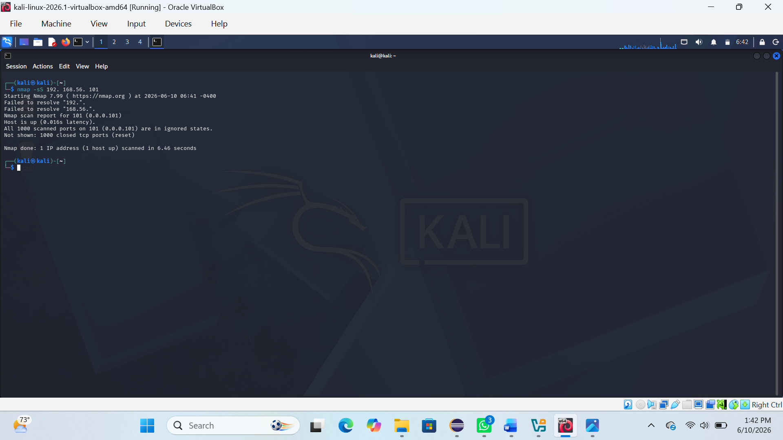

Fig 2: Scanning and service interaction
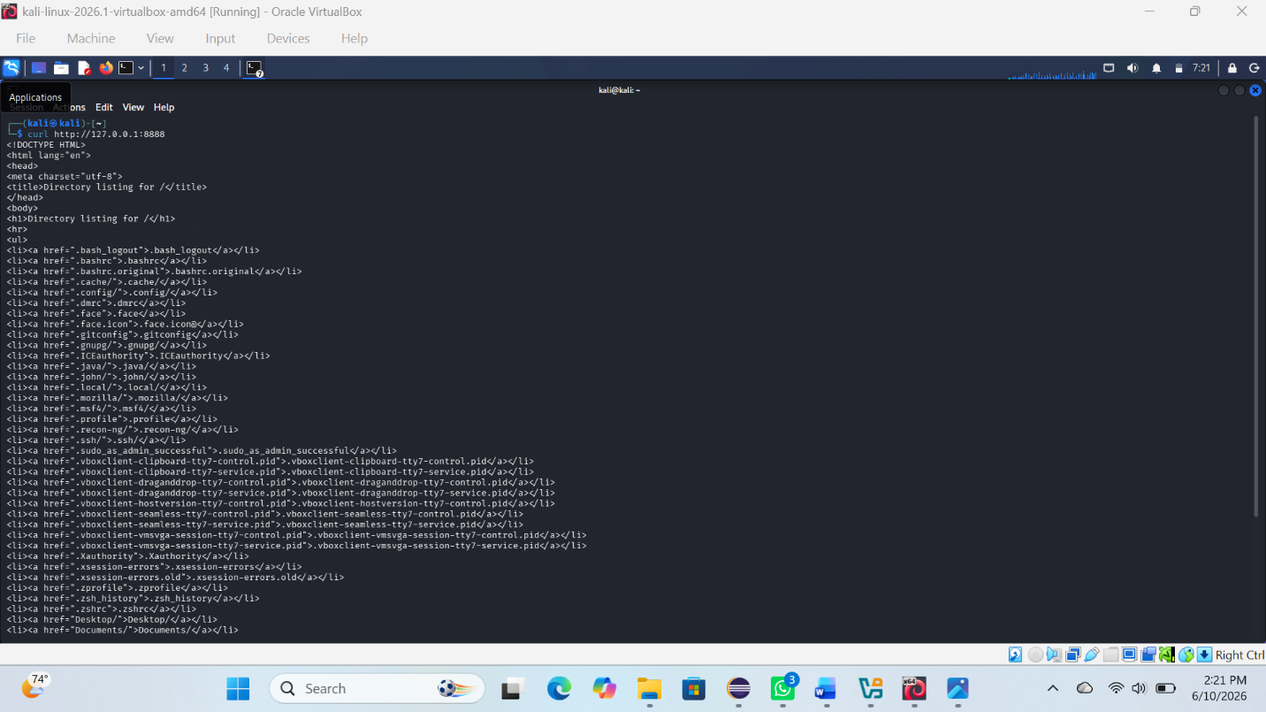
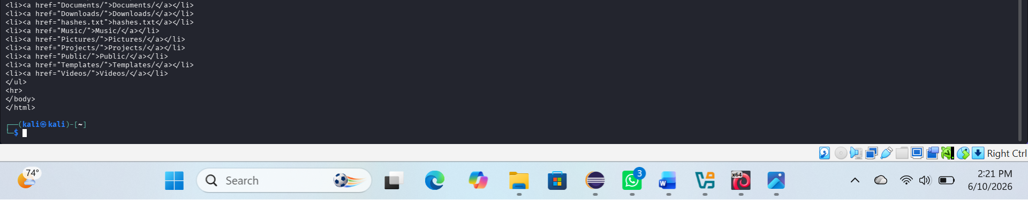

REFLECTION:
I learned how to scan networks using Nmap and Wireshark and how enumeration helps extract detailed service and system information.

